

**Retail Sales Analysis SQL Project**



* **Submitted by:**
* **Ibrar Ali 54199**
* **M.Maaz khan 59670**
* **Ujala Hussain 52775**

**Project Structure**

**Database Setup**

* **Database Creation**: The project starts by creating a database named  retail_sales_dw.
* **Table Creation**: A table named  sales_data, products_data, customer_data, store_data, sales_cleaned_data is created to store the sales data.

**SQL QUIRES :**

create database retail_sales_dw;

use retail_sales_dw

--This table will store transactional data from retail sales--

create table sales_data(

t_transaction_id int primary key,

p_product_id int,

c_customer_id int,

s_store_id int,

q_quantity int,

r_revenue decimal(10,1),

t_transaction_date date

);

--This table stores product details--

create table products_data(

p_product_id int primary key,

p_product_name varchar(50) not null,

c_category varchar(25) not null,

p_price decimal(10,1)

);

--This table stores customer information--

create table customer_data(

c_customer_id int primary key,

c_customer_name varchar(50) not null,

g_gender varchar(15),

a_age int,

e_email varchar(25) not null

);

--This table contain store information--

create table store_data(

s_store_id int primary key,

s_store_location varchar(25) not null,

m_manager_name varchar(50) not null

);

--Load Data--

--Create final cleaned sales Table--

CREATE TABLE sales_cleaned_data (

t_transaction_id int primary key,

p_product_id int,

c_customer_id int,

s_store_id int,

q_quantity int,

r_revenue decimal(10, 1),

t_transaction_date date

);

### Data Exploration & Cleaning

* **Record Count**: Determine the total number of records in the dataset.
* **Customer Count**: Find out how many unique customers are in the dataset.
* **Category Count**: Identify all unique product categories in the dataset.
* **Null Value Check**: Check for any null values in the dataset and delete records with missing data.

select sum(r_revenue) as total_revenue

from sales_cleaned_data;

select sum(q_quantity) as total_quantity_sold

from sales_cleaned_data;

select sum(q_quantity) as average_revenue_per_transaction

from sales_cleaned_data;

--removes duplicate records--

select t_transaction_id, COUNT(*)

FROM sales_data

GROUP BY t_transaction_id

HAVING COUNT(*) > 1

--Data Integration--

--Join tables to combine information--

select sales_data.t_transaction_id, products_data.p_product_name, customer_data.c_customer_name, store_data.s_store_location, sales_data.r_revenue, sales_data.t_transaction_date

from sales_data

join products_data ON sales_data.p_product_id = products_data.p_product_id

join customer_data ON sales_data.c_customer_id = customer_data.c_customer_id

join store_data ON sales_data.s_store_id = store_data.s_store_id;

### Data Analysis & Findings

The following SQL queries were developed to answer specific business questions:

1. **Write a SQL query to retrieve all columns for sales**

--Total revenue per product--

select products_data.p_product_name, sum(sales_cleaned_data.r_revenue) AS total_revenue

from sales_cleaned_data

join products_data on sales_cleaned_data.p_product_id = products_data.p_product_id

group by products_data.p_product_name

order by total_revenue desc;

--Total revenue per customer--

select customer_data.c_customer_name, sum(sales_cleaned_data.r_revenue) AS total_revenue

from sales_cleaned_data

join customer_data on sales_cleaned_data.c_customer_id = customer_data.c_customer_id

group by customer_data.c_customer_name

order by total_revenue desc;

--Total revenue per store--

select store_data.s_store_location, sum(sales_cleaned_data.r_revenue) AS total_revenue

from sales_cleaned_data

join store_data on sales_cleaned_data.s_store_id = store_data.s_store_id

group by store_data.s_store_location

order by total_revenue desc;

-- Maximum and Minimum revenue per transaction--

select max(r_revenue) as max_revenue, min(r_revenue) as min_revenue

from sales_cleaned_data;

--Average quantity Sold per Transaction--

select avg(q_quantity) as average_quantity_sold

from sales_cleaned_data;

Some important Output Command

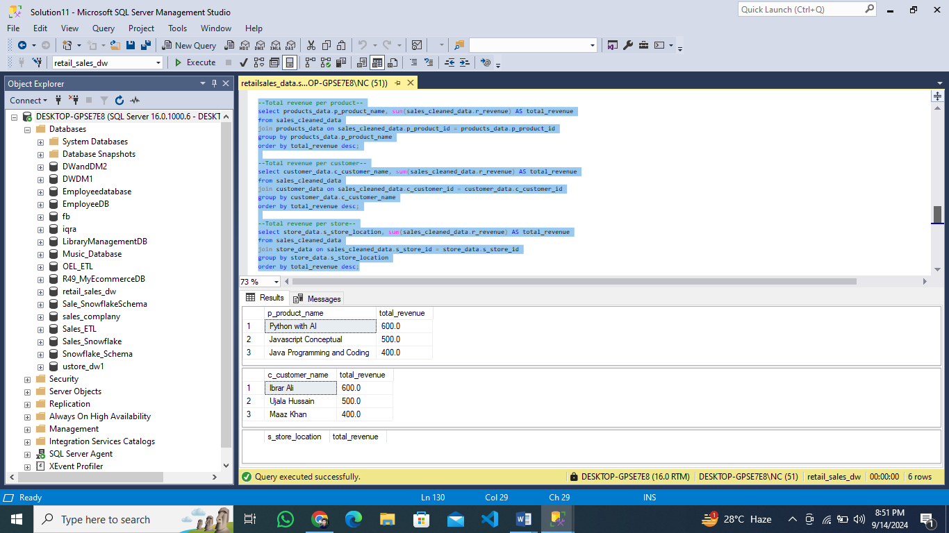

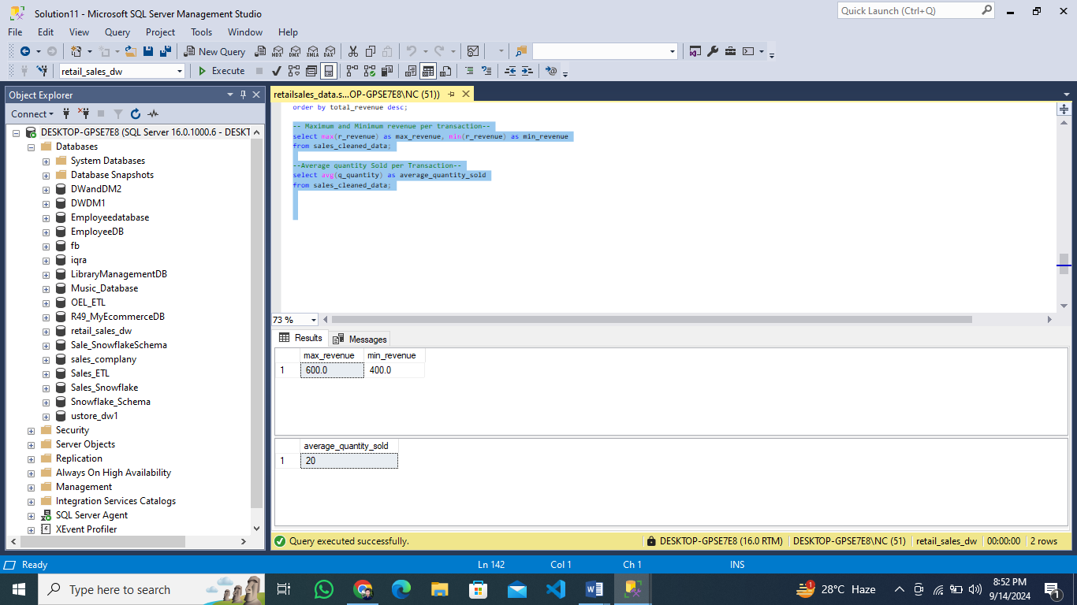

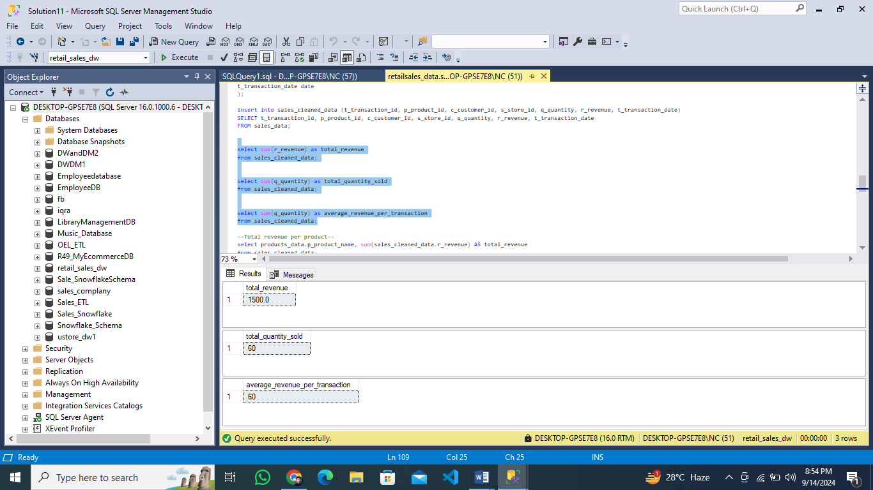

Dashboard Report on Power Bi

Connect dataset retail sales data company to implement the data analytical technique and also visualize the company data.

* **Sales Summary**: A detailed report summarizing total sales, customer demographics, and category performance.
* **Trend Analysis**: Insights into sales trends across different months and shifts.
* **Customer Insights**: Reports on top customers and unique customer counts per category.

